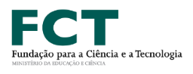
Cosmopolitanism

Justice, Democracy

and Citizenship without Borders

3 December 2019
NOVA LAW SCHOOL
NOVA University of Lisbon
Campus Campolide 18, Room 10
11h –13h

The treatment of Muslims in France: an example of discrimination disguised by human rights

​

Christopher Pollmann,

Faculté de Droit

Metz, France

