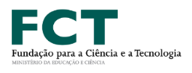
Cosmopolitanism

Justice, Democracy

and Citizenship without Borders

8 November 2019
NOVA LAW SCHOOL
NOVA University of Lisbon
Campus Campolide 18, Room 10
11h –13h

Filosofia

da Arqueologia

Íris Beatriz Borges
University of Lisbon

